Went through various available tools for cross browser testing:

Following are the finding:

LambdaTest :

All browsers and versions.
All Operating Systems.
All mobile devices.

Feedback : Easy to use and learn. Good speed. Screenshots and video recoring available.

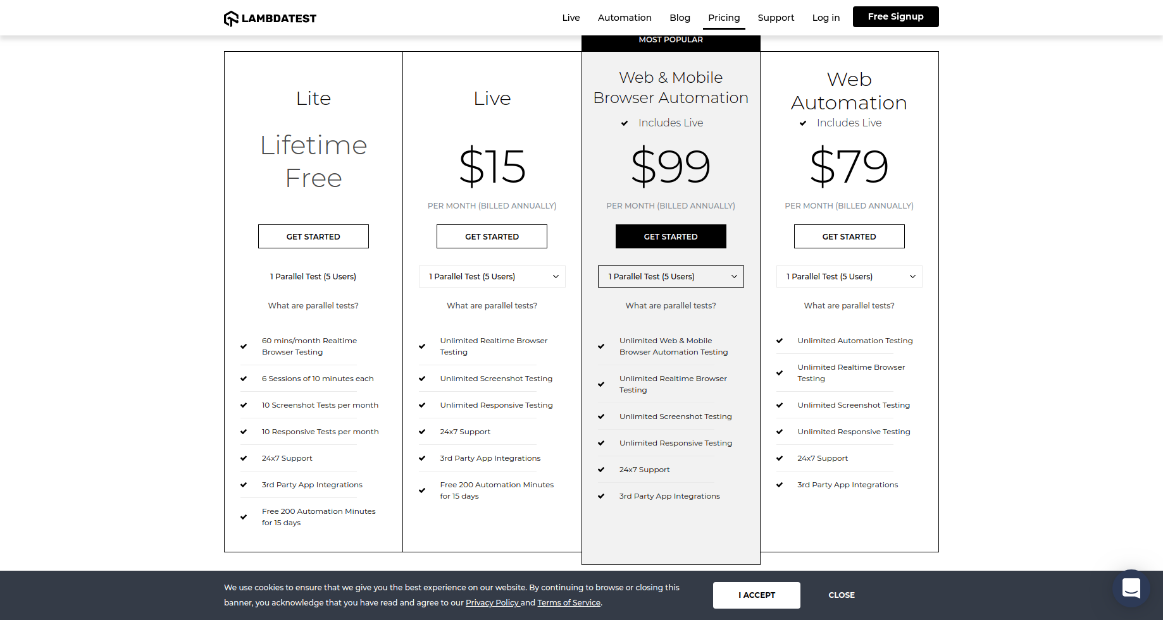
https://www.lambdatest.com/pricing

CrossBrowserTesting

It is mostly similar to browerstack in look and feel.

Feedback : All devices, browsers and OS are available that we generally use.
Intutive and easy to use environment.
Screenshots and video recoring available.

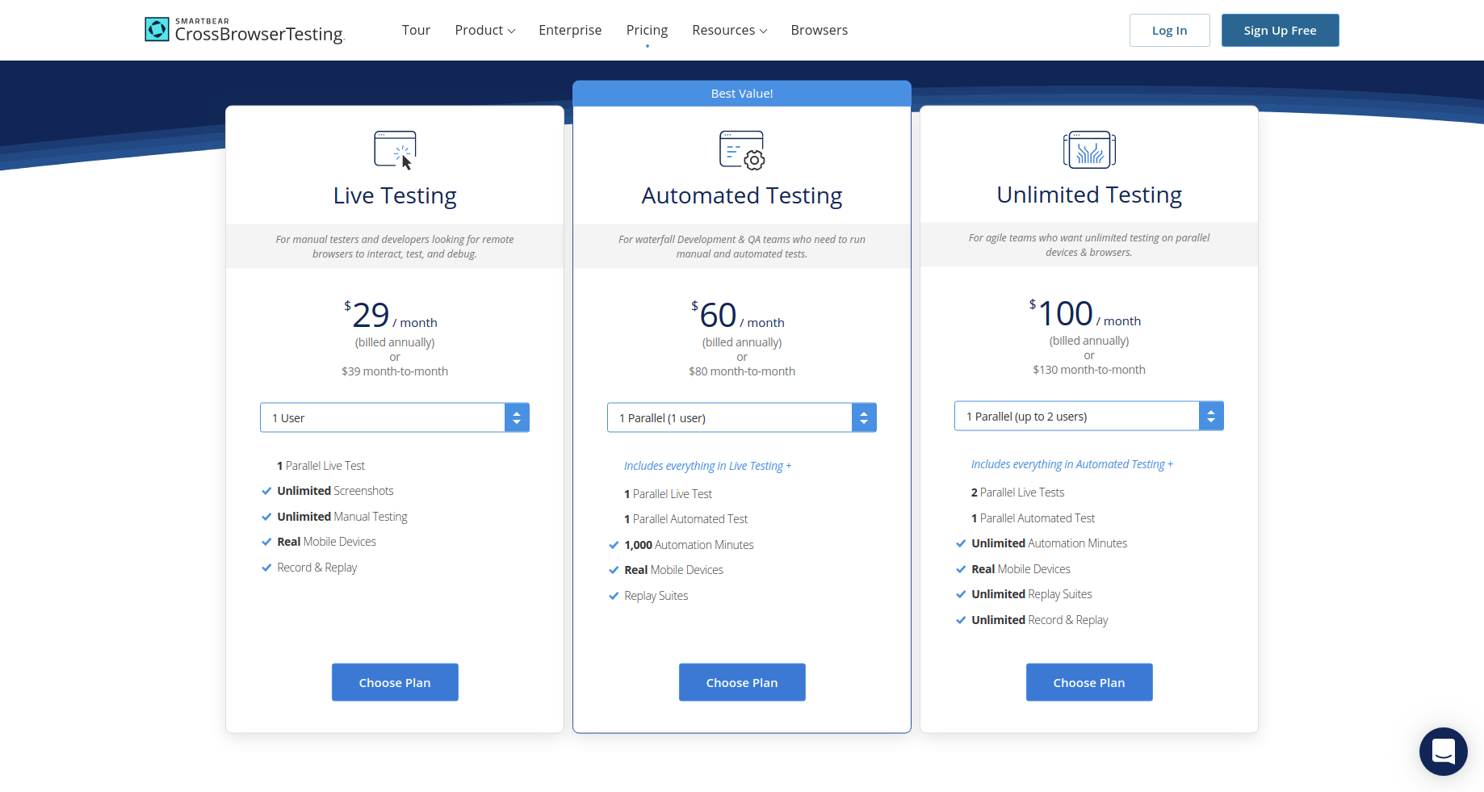
https://crossbrowsertesting.com/pricing

SauceLabs

Feedback : Does not provide mobile device tesing, they have separate section for mobile app testing where user can uplaod their mobile apps and test on various devices.

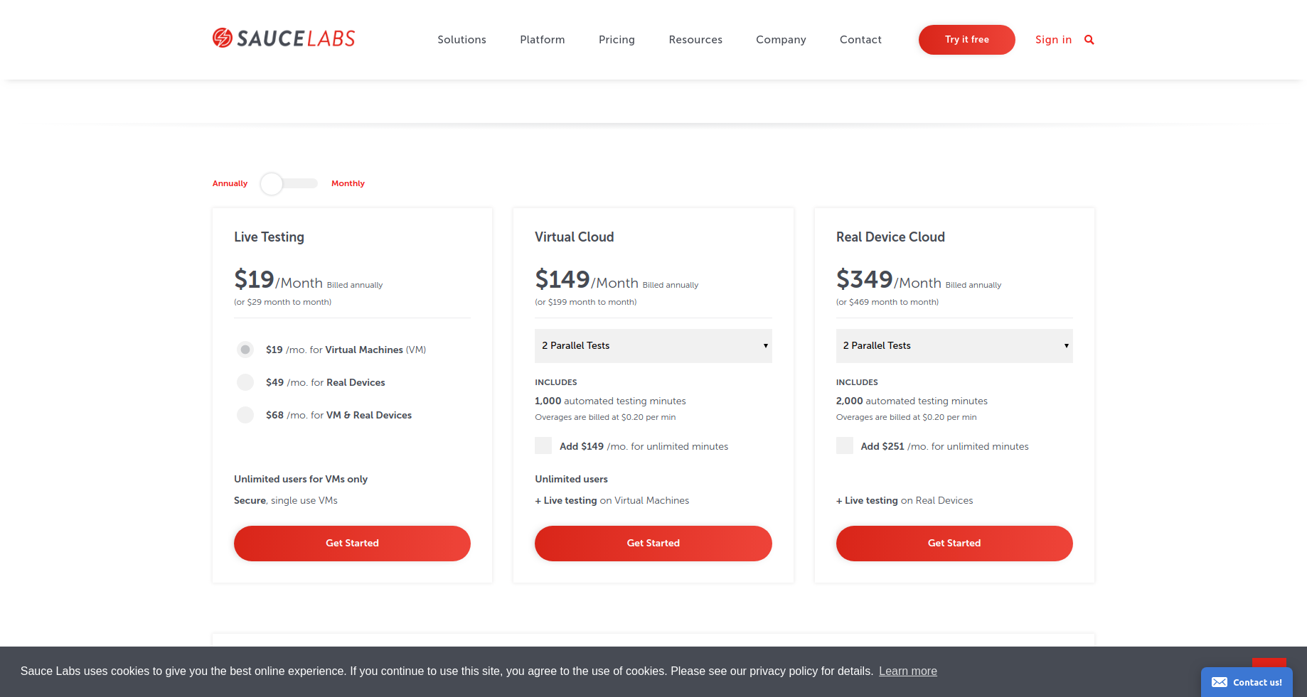
https://saucelabs.com/pricing

Experitest :

Lesser number of browsers, OS and mobile devices as compared. Easy to learn and use.

Feedback : Problem while entering “@”.
There is some reservation system for mobile devices to be used.
Screenshots and video recoring available.

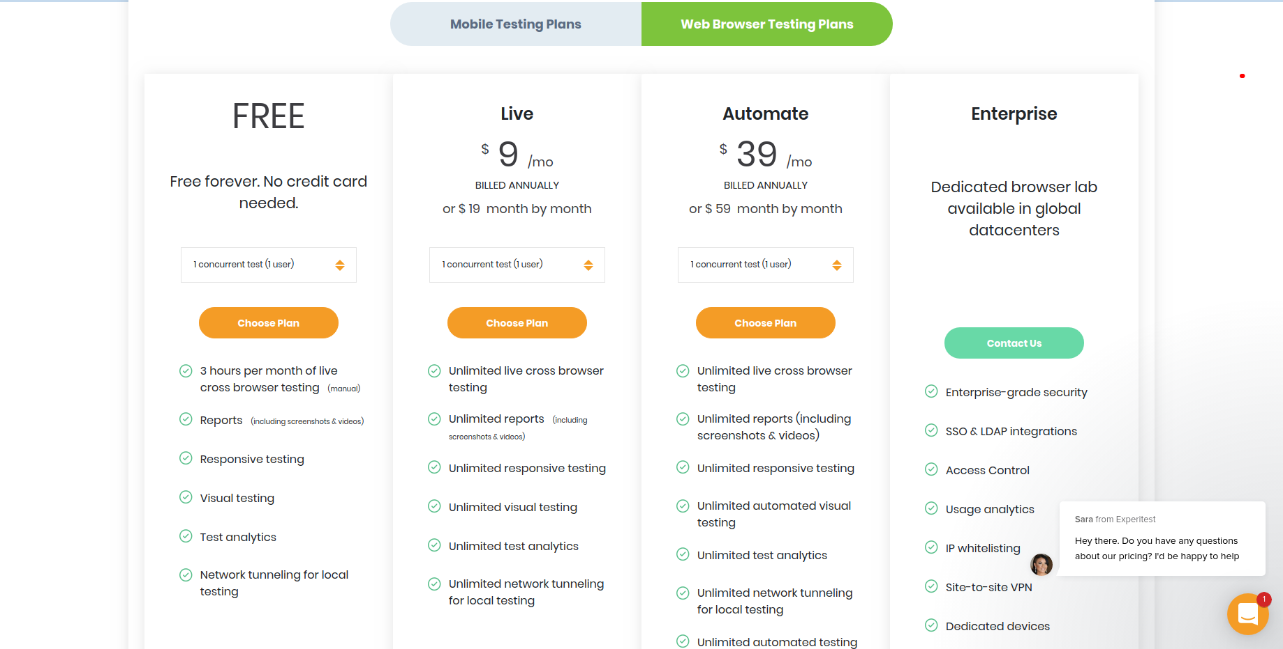

Apart from these there are some other tools also but are mostly dominant in automation for cross browser testing.

https://www.mabl.com/pricing
https://endtest.io/pricing

From testing point of view we would suggest Lambda Test.

